End of Project Report
FOR
Volunteer Management System
(VMS)

CLIENT | The Client
PROJECT | Volunteer Management System (VMS)
TITLE | End of Project Report
ADVISOR | Robert Firth
VERSION | 1.0
DATE | 31 Dec 2011

Team:
SE18 Team 08 Saturday

Dio Phung
Jiang Jifa
Thida
Hazel
Zaw
Feng Yan
Peishan

Abstract

This report is to give an overview of the Volunteer Management System project delivered by the SE18-T08S team as a deliverable for a Non-Government Organization (NGO). This report will start with introducing the related backgrounds as well as the high-level business requirements, which form the context of the project. Sequentially, the report will explain the team’s development methodology as well as the project management strategy that helps in delivering the project. It will discuss the team’s decisions that were made in various SDLC processes such as Requirements Gathering, Analysis and Design, Implementation and Testing. The report will move on to study certain challenges faced by the team as well as how the team had overcome these challenges. Finally, this report will perform an overall evaluation of how the team have performed and recommend any potential future works for the project.

Table of Contents

1. Introduction 4
2. Background 4
2.1 Business Context 4
2.2 Technical Background 4
2.3 Project Management 4
3. Project Development 5
3.1 Requirements and Planning Phase 5
3.2 Analysis and Design Phase 6
3.3 Implementation and Testing Phase 9
4. Evaluation 11
5. Conclusion 11

Introduction
The project is to build a quality software product for a Non-Government Organization to manage its voluntary activities. The system will be an integrated Web-based portal that is capable of performing Project Management, Volunteer Management and Reporting tasks. The final product is able to efficiently solve the problems of volunteer recruitment and retention, project communication, and project status tracking via a user-friendly Web-based interface.
To achieve that, the team has performed requirements analysis and risk estimation that led to decision that the team will follow Rational Unified Process (RUP) to develop this product. The whole project will be split into 3 phases: Requirements and Planning Phase, Analysis and Design Phase and finally Implementation and Testing Phase.
On a high level architecture, the system will be modular, component-based and consists of 3 layers: data layer application layer and presentation layer. As a matter of fact, an object oriented programming language, with a free open-source database and an open-source web server will be used which allow the team to obtain maximum portability and minimize the cost for development.

Background

Business Context
The client, Gawad Kalinga (GK), is a Non-Government Organization (NGO) that focuses on doing voluntary projects in Philippines. As the organization grows, it is facing severe operational challenges due to manual volunteer registration process, paper-based status tracking and lacking of report tools. Understanding the business requirements, the team initiated the Volunteer Management System (VMS) project in order to develop a system to facilitate GK in coordinating and managing its projects and volunteers.

Technical Background
Seeing the growing popularity of Internet-enabled devices and the related Web-based technology, the team decided to build the system with a Web-based interface which will provide maximum outreach to potential pool of volunteers. Thanks to it, the NGO will not need to ask users to install or download separate application while still able to allow its staff to access the system from anywhere at any time. In short, a Web-based system will help the NGO in optimising its business of doing voluntary works.
Also understanding the budget limitation from a charity organisation, the team has decided to build the system based on total open-source platform that minimize the total cost of ownership while maintaining maximum quality. Therefore, the System is built using the object-oriented programming language - Java 6, the popular database management system – MySQL 5 and JasperReport for reporting. The team has also made use of free and high quality frameworks - Spring 2.5 and Hibernate to facilitate the development process.

Project Management
To kick off the project, the team formed its organisational structure with one appointed Project Manager, one Quality Manager, one Technical Lead and four other members consists of Developers and Business Analysts. The assignment of role and responsibility is done based on the individual level of capability, commitment as well as passion.
By studying the scope of requirements, analysing the team skills set and the capability level of each resource, the Project Manager confirm to follow Rational Unified Process with Waterfall SDLC, which will split the whole project into 3 major phases:
- Requirements and Planning: to form the baseline of requirement, to define initial project plan and to construct the project quality plan.
- Analysis and Design: to analyse the requirements and provide the high level design of the system, to develop and study the prototype in order to verify the feasibility of the chosen strategies.
- Implementation and Testing: to develop the actual system and to conduct necessary quality management activities to ensure a quality product.

Project Development
By applying RUP methodology and Waterfall SDLC, the project is split into 3 phases with each major deliverables as the following:

Requirements and Planning Phase
This phase consists of activities to define and scope the user requirement, determine how to manage the project risks (if any) and to fully plan-out the project. In this phase, the team has organised the structure by appointing important roles for project such as Project Manager, Quality Manager, Technical Lead, Business Analyst and Developer.
After that, two appointed Business Analysts were in charge of gathering User Requirements. Together the appointed User Manager, Project Manager, and Quality Manager, they have produced following deliverables:
- User Requirement Specification: this is the final set of requirements that state the expected functionalities of the system, as well as related operational and non-functional requirement for the final product.
- Project Plan: this document defines the strategy for the project team to successfully produce all required deliverables. Using Function Point Counter (FPC) and COCOMO software, it is estimated that the project will last for 11 months with over 524 man-days
- Quality Plan: this document defines the methods and procedure that the team must follow throughout the projects. It is served as the quality guidelines and the checklist for the team to follow, and to provide evidence of compliance to serve the auditing purpose. The Quality Plan emphasized on the importance of compliance and auditing evidence in order to deliver a quality product. Quality Manager did guide the team on how to stay compliant with the Quality Plan as well as how to produce quality management artefacts.
Nearer to the end of the first phase, the client indicates that they may not want to continue with the current scope of the system since they have already triggered implementation of similar system in their head quarter in the Philippines. The team then consulted the project assessor and estimated the risks of changing project scope; after all, it is decided that the team should go on with the original set of user requirements, appoint one member as the putative User Manager while still continue to look for other potential customer.
At the end of this phase, the team went through the first audit meeting with the project assessor to validate and ensure the deliverables were up to the standards defined in the Quality Plan. In general, the deliverables complied with the quality procedures defined in Quality Plan and the met original requirements. However, there are small leftovers that need to be pursued and resolved in subsequent phase. It was documented and recorded in project meeting minutes.

Analysis and Design Phase
After Requirements and Planning Phase, it is realised that the team need to produce a system prototype to test various aspects of the to-be-built System, which include usability research and technical feasibility analysis. Therefore, the team were assigned these following tasks:
- Produce a prototype based on initial User Requirements Specification
- Perform Prototype demonstration to the putative User Manager to gather feedback and more inputs on usability.
By finalising the URS, the Application Architecture Overview is specified:
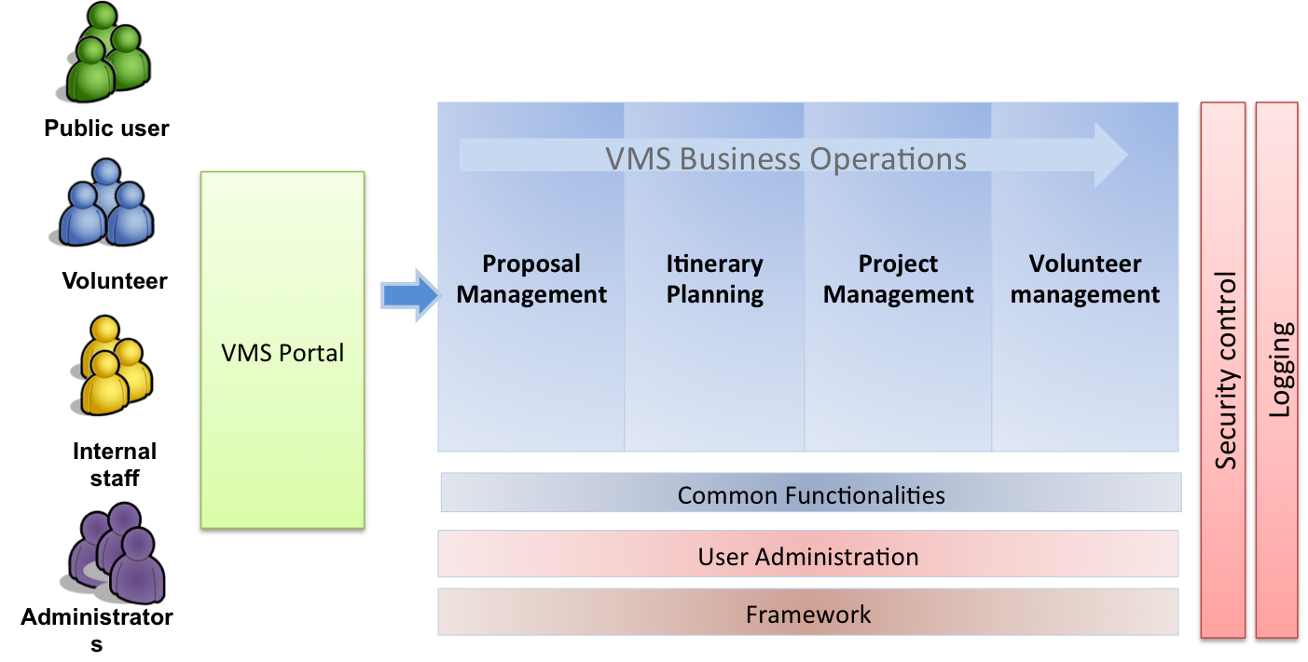
Figure 1 – Application Architecture Diagram

Subsequently, the Technical Lead, Development Lead and Quality Manager finalise the design choices and design considerations as in the following table:

Design item | Technology used | Design consideration / Rationale
Client | - Internet Explorer 7, Firefox 4.0 and later | - To produce a web-based system that support most popular browsers (up to the point)
Web layer | - Apache Web Server 2.2  - Sitemesh  - JSTL  - DWR | - Sitemesh, JSTL, DWR are both flexible and versatile technology that are proven in the industry  - The technical lead and majority of other team members already had few years of experience working with those technologies.
Application layer | - Spring MVC Framework  - Hibernate Framework  - JasperForge (iReport and JasperReport)  - Apache Tomcat | - Spring MVC Framework and Hibernate Framework are two most popular frameworks that can fully support the development cycle with proven quality and predictable result.  - JasperReport and iReport are also popular and proven products/technologies that can help in reporting.  - Apache Tomcat was chosen over other App Servers because of the fact it is lightweight, flexible and more stable. Furthermore, the technical lead is also more familiar with Apache Tomcat since he is using it at works. The prototype also proved the ease of deployment and maintenance on Tomcat.
Database layer | - MySQL 5 | - MySQL is a popular and open-source RDBMS which is just suitable for the development platform. It offers both versatility and durability that meet the team requirements for development.
Table 1 Design choices and consideration
The above design considerations are combined in the technologies stack to form the high level software architecture of the project:
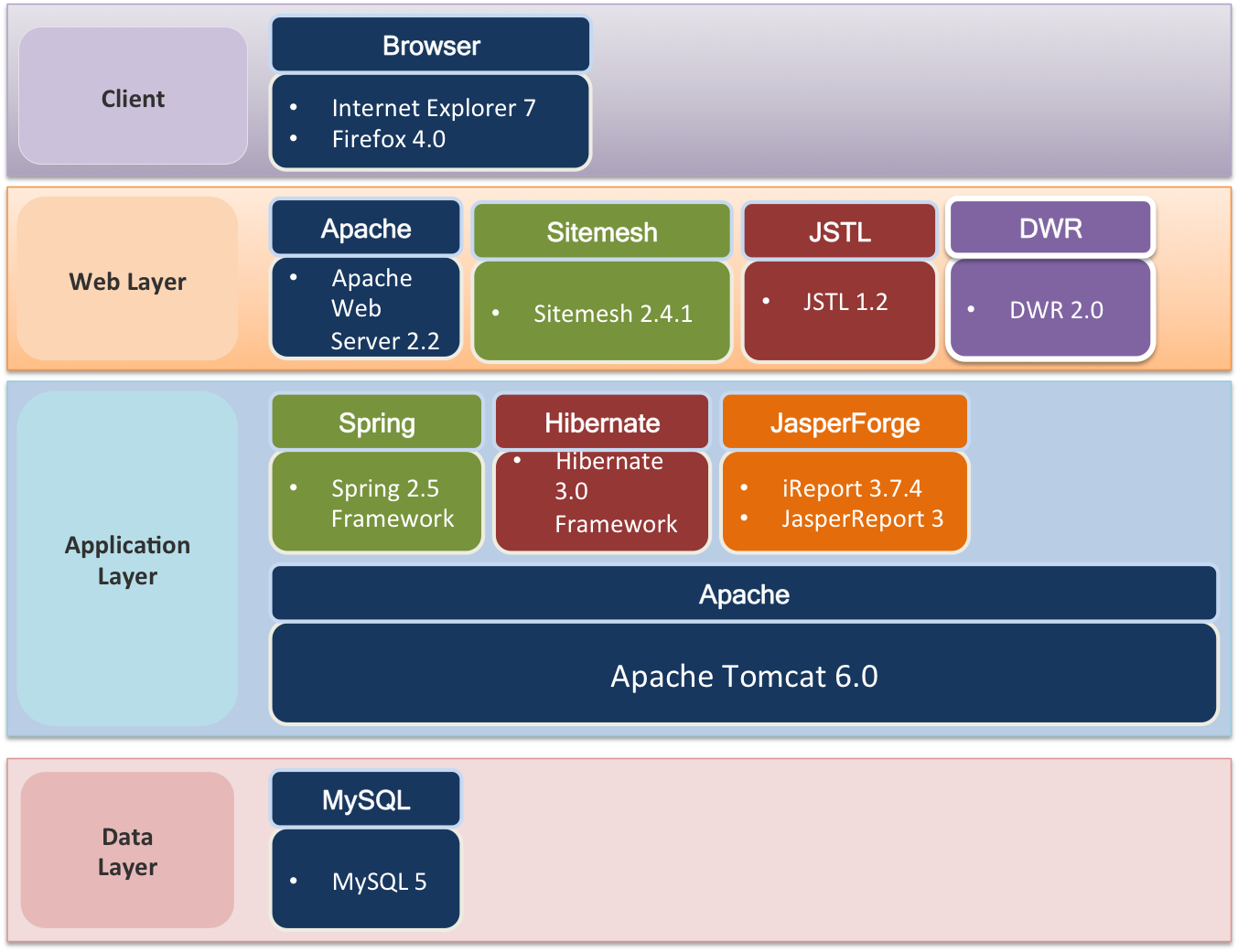
Figure 2 High level software architecture
Similarly, the chosen technologies are combined and form the logical application component viewpoint as the following:
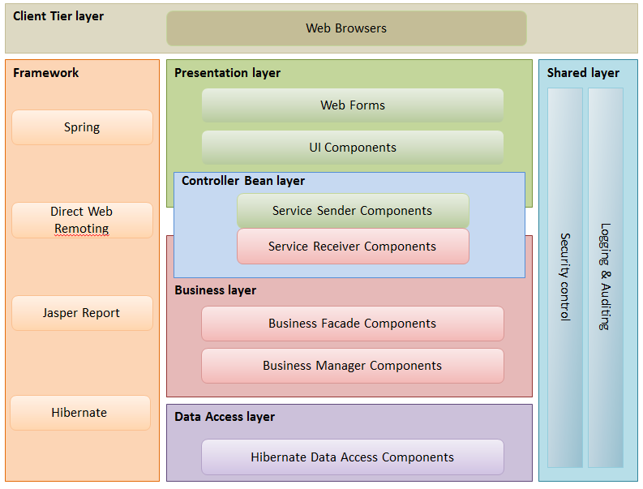
Figure 3 Logical application viewpoint
In the logical application design, the shared layers such as Security and Common Utility (Logging & Auditing) will cater for all tiers across the system. This is to support the code reusability and to follow the DRY (Do not Repeat Yourself) principle.
Next, the overall Use Case Model Survey and Use Case Realisation Report (Analysis) are created to capture the use case flow and object model for each use case. Totally there are 20 use cases were captured in UCMS.
Finally, the Project Manager requested the Technical Lead and Development Lead to define the High Level Design Specification that captured and explained the following points:
- High level software/hardware architecture
- Overview of technologies and tools to be used in development phase
- Project Source Code Structure setup
- Guideline for development in Presentation, Business Logic and Persistent Tier
- Guideline for other tools and utility used in development (JasperReport, Ants)
- Guideline for convention and other best practices
At the end of this phase, the team meet again with the project assessor to go through the second audit to confirm that the design considerations are appropriate. The output of this phase is the following deliverables:
- Functional Specification: include the Use Case Model Survey and Use Case Realisation Report (Analysis) for each use case
- High-level Design Specification: include the proposed software/hardware architecture for the development
- Prototype Study Report: present the study based on the prototype to analyse the technical feasibility and usability of the final product.

Implementation and Testing Phase
Implementation and Testing Phase kicks in as the last development phase for the project. Since there is still no actual user in this phase, the putative User Manager is excused and the team has agreed to de-scope certain testing activities. As advised by the project assessor and defined in the Project Plan, the team have performed the following activities:
- Defining the Software Change Management (SCM) Procedure, with the help of SVN and Eclipse SVN plugin to facilitate the development team
- Designing the Detailed Use Case Realisation Report (Design), one for each use case
- Reviewing the UCRR (Design) to confirm the correctness of such diagrams and flows.
- Defining the development and integration strategy that revolves around the inter-dependence and importance of modules. The building order is as follow:

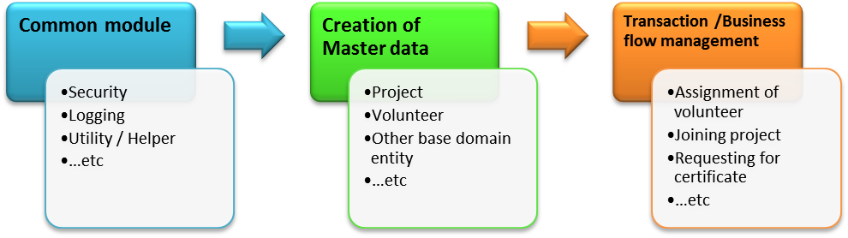
Figure 4 Order of development

- Perform actual code development, at the same time conducting code walkthrough, peer-review to ensure correct understanding and implementation at unit code level.
- Defining the test cycles, with all related testing activities such as defining entrance criteria, exit criteria, deliverable KPI. For System Integration Test, the team setup the test environment; prepare the test data, defining the test cases versus the User Requirement Specification and the Functional Specification. The testing procedure in the SIT is as followed:
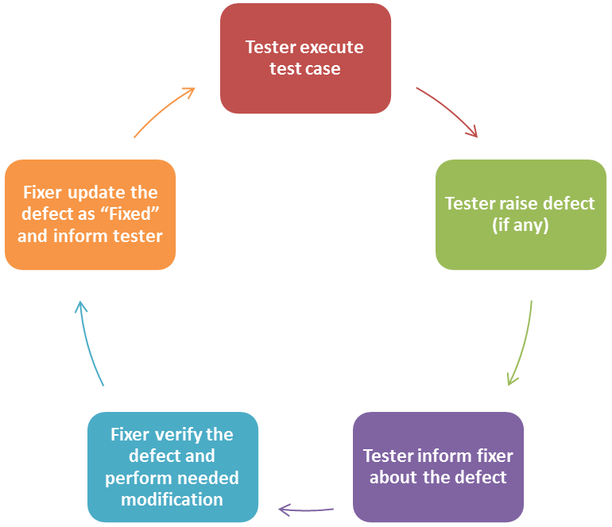
Figure 5 Testing cycle

When the test results meet the exit criteria and consider ready for final phase, the Test Manager inform the Quality Manager and Project Manager about the quality of the project. By that time, the PM and QM decide that the project have met the final exit, thus the team has successfully deliver the project according to the Project Plan and Quality Plan.

Evaluation
Throughout 11 months, the team has conducted 3 phases: Requirements and Planning, Analysis and Design, Implementation and Testing and delivered the required deliverables.
Over these phases, the most notable challenge is the missing of an actual user. This issue poses great challenges on defining actual User Requirements as well as to follow pre-defined activities such as User Acceptance Test or User Sign-off. However, the team has actively appointed one member to serve as a representative User Manager. Meanwhile, the team have also progressively sought out for potential customer of the product.
Since the beginning of the project, the team has understood the importance of defining comprehensive and exhaustive sets of SDLC processes, guidelines and quality control mechanism to ensure the successful deliverable of the final product. Those artefacts include Project Plan, Quality Plan and all Design documents. They served as the benchmark and checklists to perform the subsequent activities.
In general, the team have strictly followed these mechanisms ranging from creating meeting minutes, performing documents review or auditing / tasks verification. The Quality Manager proactively managed and controlled the whole process with her extensive experience in Quality Management. It turns out that the final product passes 100% number of test cases with no critical and high priority bugs.
In terms of qualitative aspect, the team has put the quality on top since the beginning. The team considered and strict followed various Quality Control mechanisms such as every release document must have review, every task must have audit, every meeting must have meeting minutes.
However, due to the time constraint of each project member at the end of the project phases, there are several defects left over on the final deliverables such as remaining medium and low priority bugs. It is also noted that due to lack of business background and domain knowledge, the Functional Specifications still contains drawback and certain use cases are not applicable in actual context.
Finally, not all of the Project Management processes were not aggressively pursued and enforced. Due to the nature of remote team where certain member is not able to meet up for status reporting or project meeting, there were times when the team members were not aware of current status and what are needed to be accomplished by certain time. The Project Manager can do the tasks better by closely follow and actively engage the team member to perform status report for the tasks on his/her hands.

Conclusion
After more than 11 months, the team has successfully delivered the project that meets the requirements and design specifications. The overall quality of the system also meets the exit criteria defined in the Test Plan and Quality Plan. The final output is proved to be capable system for any voluntary organisation to coordinate and manage its operations and volunteers.
This year-long development project has emphasises the importance of continuous commitment and progressively development in meeting the deadline and meeting the target quality. In fact, the overall project development processes can be improved if the team employed more regular checkpoints or status reports. The Technical Lead and Development Lead can even consider the combination of Scrum and Agile SDLC into the Implementation and Testing phase in order to cope with the possible change in the requirements.
The product has potential wide application. Few initial surveys with different NGOs shows that many developed NGOs don’t have their unified volunteer management systems. Given the similarity in the needs of different NGOs, the project is proven to be scalable flexible enough to fit in each NGOs. As a modular system, one can extend and improve the functionality of the current systems with minimum efforts and costs.

Acknowledgement

We would like to express our sincere thank and heartfelt gratitude to our lecturers at ISS who have been giving us many interesting and intellectually intriguing challenges. Thanks to their valuable lessons and experience, we have been able to successfully complete our project and accomplish our year-long goals.

We would also like to thank Gawad Kalinga Foundation who has inspired us and provided us with insights and useful information to serve as the crucial inputs for our system designs.

Furthermore, our gratitude is for our beloved ones including family and friends who have provided great supports over the year. We would have not been able to finish the journey without their constant encouragement and special understanding.

And last but not least, it is great thank-you to all members of our dear team. Throughout the year-long journey, we have worked side-by-side to perform lots of hard-work and some even scarifying personal commitments to devote time for the project. We have demonstrated that the combination of youth, energy, positive attitude, determination and professionalism is a perfect recipe to overcome any challenges.

Bibliography

The list of reference, books and articles goes here.

[1] Richard Brickson, “Design Patterns”, Amazon Pte. Ltd., 2011

[2] R.Ritche, “Software Architecture”, Plexton, 2000.

[3] Walter Isaacson, “Steve Jobs biography”, Amazon Pte. Ltd., 2011.

[4] VMS Manual, SE18 Team 8S team, “User Guide”, 2011.

Appendix

